Secure Application Programming
Project Template

Student Name: Rediet Berhe
Student Number: 21238383
Module: Secure Application Programming
Date: 01/12/2025

Revisions

Version | Primary Author | Description of Version | Date Completed
V1.0 | Rediet Berhe

Table of Contents

Table of Contents
Software Development Lifecycle Methodology 2
Introduction 3
Software Requirement Specification: 5
General Description: 3
Requirements : 3
Functional Requirements: 3
Non-Functional Requirements: 3
Data Classification: 4
Entity Relation Diagram (ERD): 4
Technical Specification: 5
High-Level Architectural Diagram 5
Wireframes: 5
Use-Case Diagram: 7
Use-Case Description: 8
Class Diagram: 12
Sequence Diagram: 12
Testing Plan 13
Discussion on the Insecure Code: 13
Discussion on the Secure Code: 13
Ethics Question: 13
Appendix A Breakdown of Marks 14
Appendix B 14

Software Development Lifecycle Methodology
Choose two Methodologies from the following list. Provide an explanation of your understanding of both. Make a detailed comparison of each and provide a justification why you would use one over the other.
- Waterfall:
- Agile Iterative Model:
- Spiral Model:
- V Model:
- Rapid Application Model:

Agile Iterative Model:
Each iteration delivers a small, working slice of functionality that is planned, built, tested, and reviewed with stakeholders. Requirements and priorities may evolve between iterations based on feedback.
Key characteristics:
- Short iterations
- Continuous customer/ stakeholder feedback and frequent demos
- Incremental delivery
- Lightweight documentation
- Adaptive to changing requirement

Pros:
- Highly responsive to changing requirements
- Early and continuous stakeholder validation reduces risk of building the wrong thing
- Problems discovered early through frequent testing/demos
- Good for teams that value collaboration and fast delivery
Cons:
- Can feel chaotic if score or priorities are unstable
- Less emphasis on heavy upfront design may cause architectural debt if not managed.
- Requires disciplined product owner and consistent stakeholder availability.
- Harder to estimate long-term schedule and cost precisely upfront

When to prefer agile Iterative
- Requirements are likely to change or are not fully known up front.
- Stakeholders want early demos and continuous feedback.
- Time-to-market and visible progress matter.
- Team is co-operative and can work in short circles.

Spiral Model
Each cycle has four main activities: determine objectives, identify and resolve risks (analysis and prototyping), develop and verify the next-level product, and plan the next iteration. Each spiral expands the system until completion.

Key characteristics
- Iterative, but each iteration centers on identifying and mitigating the highest risks first.
- Heavy emphasis on risk analysis and prototypes
- Suitable for large, complex or high-risk systems.
- Combines elements of waterfall (structured phases) with iterative prototyping.
Typical artifacts/activities
- Risk assessment and mitigation plan at each spiral
- Prototypes or proofs-of-concept for high-risk features
- Incremental deliverables that evolve toward final system
Pros:
- Explicit focus reduces chance of costly surprises later
- Prototyping enables early validation of hard technical or requirements risks
- Flexible – can adopt process intensity to risk level
- Good for systems with high technical, schedule, or safety risks
Cons:
- Can be complex and bureaucratic- needs experienced project managers/analysts.
- Most costly and time-consuming upfront
- Stakeholders must be prepared for repeated risk reviews and potentially shifting plans
- Not suited, low-risk projects due to overhead

When to prefer Spiral
- High-risk projects (strict regulatory constraints)
- Large systems where unknowns need early exploration via prototypes
- When budget/timeline can accommodate upfront risk-analysis costs

Introduction

In this project you are required to evaluate develop and implement an open-source web application that will use ether Node with Express or PHP. The database for simplicity should be SQLite3. This web application does not need to be hosted.

There should be two implementations of you application, The insecure version should contain the following.

SQL Injection flaw
Cross Site Scripting XSS vulnerability: Reflected, DOM Based and Stored.
Sensitive Data Exposure.

The Secure version of your application should rectify these vulnerabilities by providing a detailed explanation of how it was done in addition it should have the following.

Cross Site Requested Forgery Token.
Proper Session Management incorporated.
Use of Security Headers
Adequate logging and monitoring incorporated into the application.

The Web Application should be as simple as possible. This project is intended to test your understanding of secure programming concepts, not building web applications UI UX design is not important but what is important is the documentation on how you approached the design implementation and testing of the project. You may ask your fellow students to perform a code review, but this is optional and will not be marked.

The Code should be made available on GitHub. The secure and insecure versions should be separated into two branches secure branch and insecure branch, use the README.md file to provide details of any setup configuration required to run your code, and use git issues and Git Project to demonstrate project planning and implementation.

Software Requirement Specification:

General Description:
Give a brief description of your web application. keep it simple it can be a Blog Post or TO-DO list with different levels of access rights. The purpose is to demonstrate SQL Injection, XSS Vulnerabilities and Sensitive Data exposure. In the secure version you will need to provide proper logging and monitoring, Session Management, secure headers and CSRF to improve security.

Write a short paragraph describing the web application that you will build.

Project Title: Online Event Registration System
System Type: Web-Based Application
Development Approach: Dual Implementation (Vulnerable & Secure Versions)
Backend Technology: Node.js with Express
Database: MySQL
Version Control: GitHub

This project involves the design and development of a web-based Online Event Registration System implemented in both vulnerable and secure versions. The system allows users to register accounts, log in, view available events, and register for events, while administrators can create and manage events

Describe how you can incorporate Secure Application Principles into the project.
- Principle of Least Privilege
The system defines two roles admin and user
- Regular users are only permitted to view events and register for events
- Administrative users are the only ones allowed to create, update and delete events including viewing all registrations
- In the secure version, server-side role-based access control (RBAC) ensures that unauthorised users cannot access admin routes even if they manipulate events
- In vulnerable version, access control checks are missing or weak, allowing unauthorised actions

- Principle of Secure Defaults
The principle of secure defaults requires that systems be secure by default, even if the user or developer does not configure additional security controls
- In secure version – passwords are hashed by default before storage and SQL queries use prepared statements automatically
- In vulnerable version, these protected are disabled by default allowing (Plaintext password storage, SQL injection and weak session handling)

- Principle of Fail Securely
The Principle of Fail Securely ensures that when errors occur, the system fails in a secure manner without exposing sensitive information or functionality.
- The secure version displays generic error messages to users such as (invalid credentials) and Logs the full technical error details internally.
- The vulnerable version exposes raw database and server errors also reveal SQL queries internal file paths.

- Principle of Separation of Duties
The principles of separation of Duties ensures that no single user or system component has complete control over all critical operations
Implementation in the Project:
- Responsibilities are distributed between:
Users → Register for events
Admins → Manage events
- Backend responsibilities are also separated:
  - Authentication logic
  - Event management logic
  - Security validation logic
- In the secure version, administrative actions require:
  - Valid session
  - Correct role
  - CSRF token validation

- Principle of Defense in Dept

- The principle of defense in depth requires multiple layers of security controls so that if one layer fails, others still protect the system
- Implementation in the project (Multiple security layers were implemented in the secure version)
- Input validation – server-side validation
- SQL protection – Prepared statements
- Password security – Cryptographic hashing
- Session Security - secure cookies + expiration
- Request protection – CSRF tokens

Requirements :
Define your web application. Describe what you are building. Set out the product scope by detailing what it can and cannot do.

The design, construction, and critical assessment of an online event registration system in two different versions—a secure implementation and a vulnerable implementation—are the main goals of this project. Sensitive data exposure, saved, reflected, and DOM-based Cross-Site Scripting (XSS), SQL Injection, and other exploitable security weaknesses are purposefully present in the unsafe version. The secure version methodically addresses these vulnerabilities by the deployment of industry-standard security controls such as prepared SQL statements, password hashing, input validation, CSRF tokens, proper session management, security headers, and organised logging and monitoring.

The application was developed using a full-stack approach with a backend implemented in Node.js and Express.js and a relational database managed using MySQL.
By the completion of this project, a fully functional and security-hardened online event registration system was produced alongside a demonstrably vulnerable counterpart. The final deliverables include the application source code, a comprehensive security analysis report, and a demonstration video documenting both the exploitation and mitigation of each vulnerability.

Functional Requirements:

Functional Requirements ensure that the system meets user needs and supports all essential business processes. They also form the foundation for the system’s use-case diagrams and use-case descriptions.

User account management

The web application should allow a user to create a user account

The web application should allow a registered user to login using username and password

The web application should allow the user to logout the system securely

The web application should store user account information in the database

The web application should distinguish between normal users and admins based on user roles

Event management

The web application should allow an administrator to create new events.

The web application should allow an administrator to edit existing events.

The web application should allow an administrator to delete events.

The web application should display a list of all available events to users.

The web application should allow users to search and view event details.

Event Registration

The web application should allow a logged-in user to register an event

The web application should prevent users from registering multiple times for the same event.

The web application should allow users to view their registered events

The web application should store event registration details in the database

Administrator features

The web application should allow administrators to view all registered users

The web application should allow administrators to view all event registrations

The web application should restrict access to admin-only features

Security-specific functional requirements (secure version)

The secure version of the system should validate all users input on the server side.

The secure version should prevent SQL injection attacks using prepared statements.

The secure version should protect against cross-site scripting (XSS)

The secure version should implement CSRF tokens for all sensitive actions

The secure version should enforce secure session management.

The secure version should log all authentication and administrative actions

Vulnerable system requirements

The insecure version of the application should allow SQL injection

The insecure version should allow stored, reflected, and DOM-based XSS attacks

The insecure version should expose sensitive data through insecure storage or error messages.

Non-Functional Requirements:
Non-Functional Requirements define how well a software should perform they cover areas such as speed, security reliability and useability. The requirements for your web application should be Specific Measurable Attainable Relevant and Time-bound SMART. Use the chrome developer tools lighthouse feature to assist you with this section. This can provide report on the following.
- Performance.
- Accessibility
- Search Engine Optimisation SEO
- Best Practices

- Performance requirements

  - The system shall load the home page in under 3 seconds on a standard broadband connection
  - The Login process shall complete in under 2 seconds for valid credentials
  - The event listing page shall display all events in under 3 seconds
  - The lighthouse performance score shall be at least 80/100 during testing

- Accessibility requirements

  - The system shall achieve a minimum lighthouse accessibility scire of 90/100
  - All form inputs shall contain visible labels or aria-labels

- SEO
  - The application shall achieve a minimum Lighthouse SEO score of 80/100.

- Best practices
4.1 The system shall achieve a minimum Lighthouse Best Practices score of 85/100.

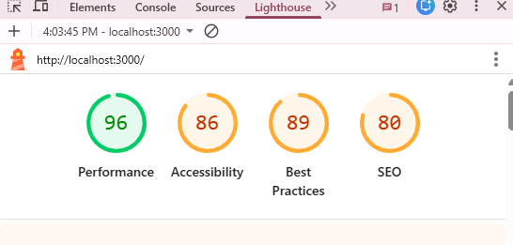

Data Classification:
Many frameworks and legal regulators have specific requirement to classify the data that is held by an organisation.

GDPR defines personal data as any information that can identify a natural person as, names, location data, online identifiers, email or IP addresses to comply with the law it is required to classify data in terms of the type of information being held financial, health etc, the basis for holding the data personal or sensitive where additional level of protection is required for race, ethnic origin, political opinion, biometric data, health data., The user has the right to know what data is held on them and has the right to be forgotten. When designing a web application, it worth incorporating features that would allow compliance with the law.

California Consumer Privacy Act gives citizens the right to request information about what types of data that is held and the right to request deletion of personal data.

Special precautions should be applied to the following types of data.
- Personally Identifiable Information PII
- Personal Health Information PHI

The first step is to create a catalogue of data that will be held and to put in place security features to prevent sensitive data exposure.

Type Of Data | Basis for collection | Security features to protect
Username | Required to uniquely identify users | Input validation, authentication checks, role-based access control
Password | Required for secure user authentication | Cryptographic hashing, secure storage, no plaintext storage, generic login error messages
Full Name | Required to identify users for event registration | Access control, restricted database access, secure sessions
Email address | Required for communication and account management | Input validation, authentication, secure session handling
User Role (admin/user) | Required to enforce access control and permissions | Role-based access control (RBAC), server side authorisation checks
Event title and description | Required to display available events to users | Output encoding, XSS protection, input validation
Event date and location | Required to allow users to attend events | Read-only public access, output encoding
Event registration records | Required to track which users have registered for events | Authentication, access control, duplicate registration prevention
Session ID | Required to maintain user login state | Secure cookies, session expiration policy
CSRF token | Required to protect against forged requests | Token validation, secure session binding
Database credentials | Required for backend database connectivity | Environment variables, restricted file permissions, no hardcoding
System logs | Required for monitoring, auditing and troubleshooting | Access restricted log files, no sensitive data in logs
IP address ( if logged) | Used for security monitoring and intrusion detection | Log access control, data minimisation, retention policy

Entity Relation Diagram (ERD):
Consider the type of data required to build your web application and create an ERD diagram.
What information is required for a user to log in Name, Email, Password are you incorporating a security principle that allows a user so many attempts before being logged out are you separating the content of your site depending on the age of the user. What would the table look like if it was displaying blog posts or a TO-DO list?

Tip this is not a real website that you are building this is an exercise in how to create an insecure and a secure web application that has a SQL injection, a stored XSS vulnerability and needs to incorporate elements of session management so think of the database in terms of how best to achieve this. Think of the security principles and how these can best be incorporated into your project will you use a hash for the user password will you be using different hashing algorithm? will you be using a database for proper logging of your application what would that table look like?

Technical Specification:
A short paragraph introducing the technical aspects of your project.

The Online Event Registration System is a full-stack, web-based application developed in two parallel implementations:
- A vulnerable version designed to demonstrate real-world web security flaws.
- A secure version that mitigates these vulnerabilities using industry-standard security controls.
The technical specification contains the architectural design, technology stack (frontend, backend, web framework, database, development tools), database schema, security architecture, and operational environment of the Online Event Registration System. The dual-system design enables a direct comparison between insecure and secure software implementations.

High-Level Architectural Diagram
Provide a high-level architectural diagram of the application describing the technologies that you intent to use. Node or PHP.

MySQL Database  -users table  -Events table  -Registrations table  -Posts  -sessions  -Failed logins  -Audit Logs | Web application  Backend REST API layer  Node.js + Express  End user  (web browser client)  HTML/ CSS/JavaScript

Provide a short paragraph describing this diagram.

The Online Event Registration System follows a three-tier client–server architecture consisting of a presentation layer, application layer, and data layer. The presentation layer is accessed via a web browser and handles user interaction using HTML, CSS, and JavaScript. The application layer is implemented using Node.js and Express and manages business logic, authentication, session handling, and security controls.

Wireframes:
Provide a wireframe of each page in your application this will help you when you come to fill out your Use-Case Description.

Page 1

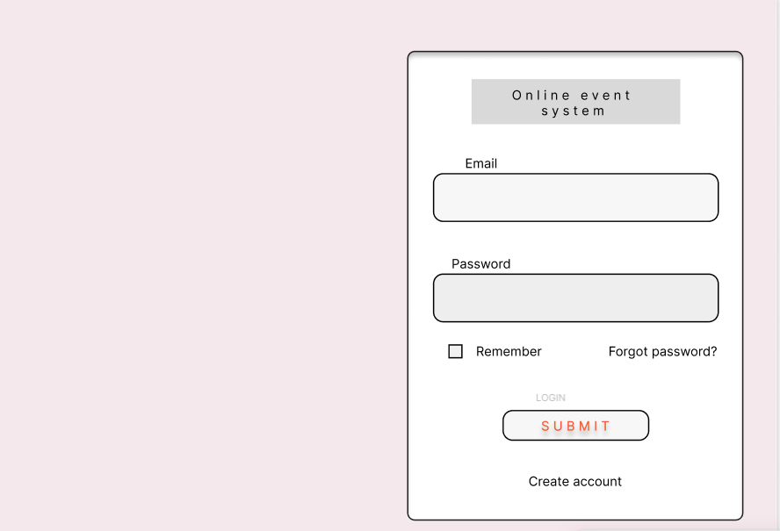
Page 2

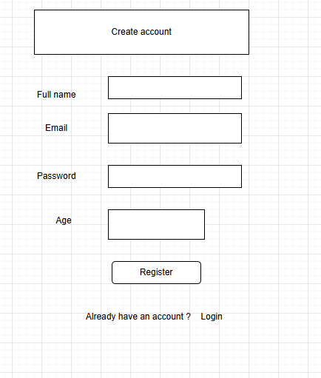

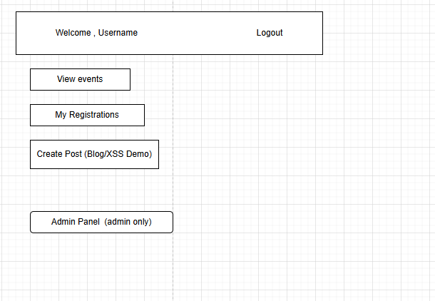 Page 3

Page 4
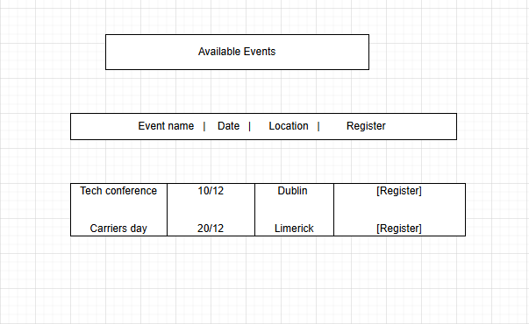

Use-Case Diagram:
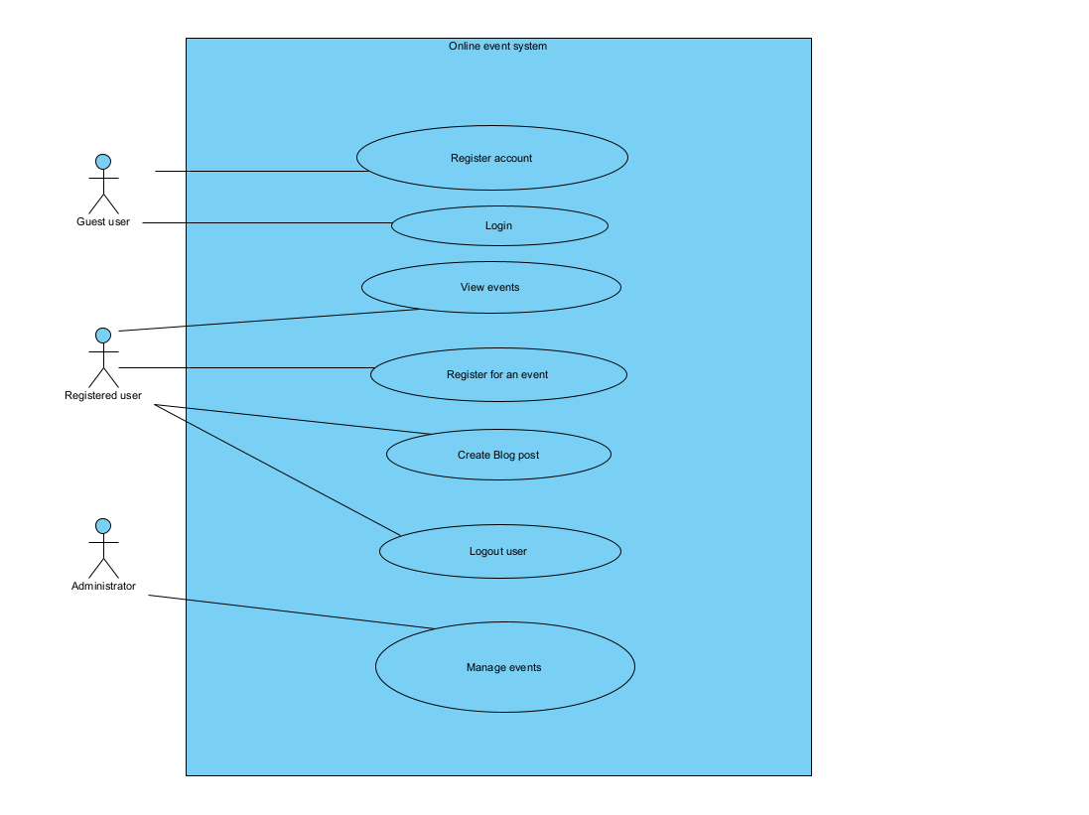
Keep use-case diagrams simple the important things to remember.
- Use-Cases are described from the perspective of the main user.
- What’s inside the system box is under your control.
- Use-case name Verb Noun if the most important aspect of this UML it should be obvious to the reader what is its function.
- For every use-case in the use-case diagram there must be a use-case description. DO NOT include ovals in this diagram that part of the use case description this is a high-level overview of the system.
- The Use-Case name must match in the use case description.
- Includes Use-Case is part of the DRY Don’t repeat yourself principle and they must always be called.
- If you find yourself with too many use-cases in the diagram you are defeating the purpose of the diagram. As a rule of thumb keep the number of use-cases to around seven if your system requires more consider splitting into more than one use-case diagram.

Use-case | Use-Case Name | Description
UC-1 | Register account | Allows a guest user to create a new user account
UC-2 | Login user | Allows a registered user or administrator to authenticate and access the system
UC-3 | View events | Allows a logged-in user to view a list of available events
UC-4 | Register for event | Allows a logged-in user to register for a selected event
UC-5 | Create Blog post | Allows a user to create a blog post with in the system
UC-6 | Logout user | Allows a logged-in user or administrator to safely exit the system
UC-7 | Manage Events | Allows the administrator to create, edit and delete system events

Use-Case Description:
Provide a brief description of each use case remember the use-case names must match the name in the use case diagram.

Use Case ID: | UC-1
Use Case Name: | Register account
Created By: | Rediet Berhe | Last Updated By: | Rediet Berhe
Date Created | 02/12/25 | Last Updated Date | 03/12/25
Description: | Allows a guest user to create a new user account
Actors:  Primary  Secondary | Guest user
Triggers: | A guest user selects the “Register” option from the login page
Pre-conditions: | The user is not logged in.
Post-Conditions: | A new user account is created in the system database.
Normal Flow: | The guest selects the option to register an account
Alternate Flows: | If the email already exists, the system displays an error message
Exceptions: | Email already exists, password too weak, required field missing
Includes:

Extends:

Priority: | High
Special Conditions: | Password must meet defined complexity rules (secure version)
Assumptions: | The system is accessed through a modern web browser.
Notes and Issues: | Vulnerable version -SQL injection is possible  Secure version- Prepared statements, CSRF protection

Use Case ID: | UC-2
Use Case Name: | Login user
Created By: | Rediet Berhe | Last Updated By: | Rediet Berhe
Date Created | 02/12/25 | Last Updated Date | 03/12/2025
Description: | allows a registered user or administrator to authenticate and access the system.
Actors:  Primary  Secondary | Primary actor – registered user and administrator  Secondary actor- authentication system/ database
Triggers: | A registered user or administrator selects the “Login” option and submits their credentials.
Pre-conditions: | The user has an existing account
Post-Conditions: | The user is authenticated and logged into the system
Normal Flow: | The user enters their email and password
Alternate Flows: | If credentials are invalid, the system displays a login error
Exceptions: | Incorrect username or password
Includes:

Extends: | Account lockout
Priority: | Critical
Special Conditions: | Account lockout enforced after repeated failures
Assumptions: | - The system is accessed through a modern web browser.  - The database server is available and operational.
Notes and Issues: | Vulnerable version -SQL injection is possible  Secure version- Prepared statements, CSRF protection

Use Case ID: | UC-3
Use Case Name: | View events
Created By: | Rediet Berhe | Last Updated By: | Rediet Berhe
Date Created | 03/12/25 | Last Updated Date | 04/12/2025
Description: | allows a logged-in user to view a list of available events.
Actors:  Primary  Secondary | Primary actor- Registered User  Secondary actor- Database system
Triggers: | A logged-in user selects the “View Events” option from the dashboard.
Pre-conditions: | The user is logged in.
Post-Conditions: | The user successfully views available events
Normal Flow: | The user selects the "View Events" option.
Alternate Flows: | If no events are available, the system displays a message.
Exceptions: | No events available
Includes:

Extends:

Priority: | High
Special Conditions: | Age restriction enforced based on event minimum age
Assumptions: | The system is accessed through a modern web browser.
Notes and Issues: | - Vulnerable version: Event descriptions may contain stored XSS.  - Secure version: Output properly escaped.

Use Case ID: | UC-4
Use Case Name: | Register for event
Created By: | Rediet Berhe | Last Updated By: | Rediet Berhe
Date Created | 03/12/2025 | Last Updated Date | 03/12/2025
Description: | allows a logged-in user to register for a selected event.
Actors:  Primary  Secondary | Primary actor- Registered User  Secondary actor- Event management system and Database system
Triggers: | User selects the “Register” button beside a specific event.
Pre-conditions: | The user is logged in and events exist in the system.
Post-Conditions: | The user is successfully registered for an event.
Normal Flow: | The user views available events
Alternate Flows: | If the user is already registered, the system displays an error.
Exceptions: | User already registered and event capacity reached
Includes: | Login user
Extends: | View events
Priority: | High
Special Conditions: | CSRF token must be validated
Assumptions: | - The system is accessed through a modern web browser.  - The database server is available and operational.
Notes and Issues: | - Vulnerable version: No CSRF protection on registration.  - Secure version: CSRF token enforced.

Use Case ID: | UC-5
Use Case Name: | Create Blog Post
Created By: | Rediet Berhe | Last Updated By:
Date Created | 03/12/2025 | Last Updated Date | 04/12/2025
Description: | Allows a user to create a blog post within the system.
Actors:  Primary  Secondary | Primary actor- user  Secondary actor- Database
Triggers: | A user selects the “Create Blog Post” option from the dashboard
Pre-conditions: | The user is logged in
Post-Conditions: | The blog post is successfully created.
Normal Flow: | The user selects “Create Blog Post.”
Alternate Flows: | If required fields are empty, the system displays an error.
Exceptions: | - Empty title or content  - Invalid input detected
Includes: | Login user
Extends:

Priority: | Medium
Special Conditions: | Output must be encoded to prevent stored XSS
Assumptions: | The system is accessed through a modern web browser.
Notes and Issues: | - Vulnerable version: Stored XSS executes.  - Secure version: Input sanitized and output encoded.

Use Case ID: | UC-6
Use Case Name: | Logout User
Created By: | Rediet Berhe | Last Updated By: | Rediet Berhe
Date Created | 03/12/2025 | Last Updated Date | 04/12/2025
Description: | Allows a user to create a blog post within the system.
Actors:  Primary  Secondary | Primary actor- Registered user and administrator  Secondary actor- Session management component
Triggers: | A logged-in user or administrator selects the “Logout” option.
Pre-conditions: | The user is logged in
Post-Conditions: | The user is successfully logged out.
Normal Flow: | The user selects the logout option.
Alternate Flows: | If required fields are empty, the system displays an error.
Exceptions: | Session already expired
Includes:

Extends:

Priority: | High
Special Conditions: | Session must be destroyed on server
Assumptions: | The system is accessed through a modern web browser.
Notes and Issues: | Secure version: Session invalidation and regeneration enforced.

Use Case ID: | UC-7
Use Case Name: | Manage Events
Created By: | Rediet Berhe | Last Updated By: | Rediet Berhe
Date Created | 03/12/2025 | Last Updated Date | 04/12/2025
Description: | Allows the administrator to create, edit, and delete system events
Actors:  Primary  Secondary | Primary actor- administrator  Secondary actor- Database system
Triggers: | An administrator selects the “Manage Events” option from the admin dashboard.
Pre-conditions: | The user is logged in
Post-Conditions: | Event data is updated successfully
Normal Flow: | The admin selects the manage events option
Alternate Flows: | If invalid data is entered, the system displays an error.
Exceptions: | Unauthorised access attempt
Includes: | Login user
Extends: | View system Logs
Priority: | Critical
Special Conditions: | Admin-only role enforcement with audit logging
Assumptions: | The system is accessed through a modern web browser
Notes and Issues: | - Vulnerable version: Role checks may be bypassed.  Secure version: Role-based access control + audit logging enforced

Class Diagram: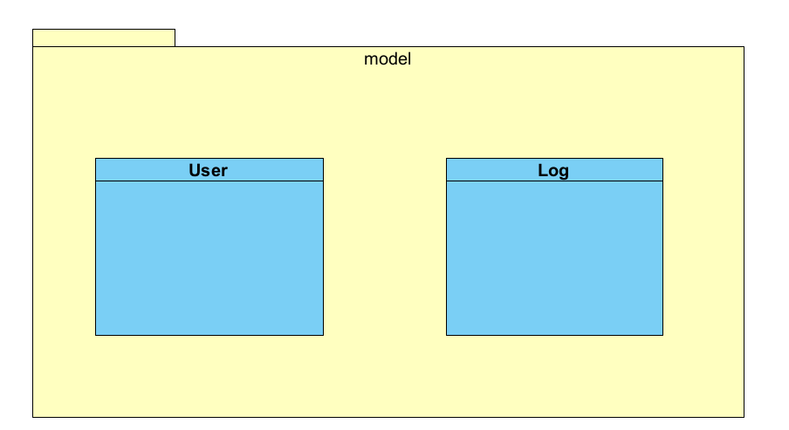
Demonstrate you understanding of Design patterns by incorporating a few of them for example Singlton or Observer patterns. In your code use The Don’t Repeat Yourself (DRY) and Solid principles. Explaining how you used the in code.

This project incorporates industry-standard design patterns, the Don’t Repeat Yourself (DRY) principle, and key Solid principles to ensure the application is maintainable, scalable, and secure.

In the Secure backend, the database connection is implemented as a singleton to prevent:
- Multiple unnecessary connections
- Resource exhaustion
- Race conditions

Secure implementation

const mysql = require(“mysql2”);
let connection;
function getDBConnection() {
if (!connection) {
connection = mysql.createConnection({
host: "localhost",
user: "appuser",
password: "securepassword",
database: "event_system"
});
}
return connection;
}

module.exports = getDBConnection();
The above implementation guarantees one shared connection and better performance.

In the secure version, the Observer pattern is applied to:
- Login attempt monitoring
- Admin event management logging

Don’t Repeat Yourself (DRY) Principle

This principle states that no piece of logic should be duplicated across the system.

Instead of repeating authentication logic in every route: I used the following in my code implementation to eliminate copy-paste coding

app.post("/admin/create-event", verifyToken, verifyAdmin, handler);

SOLID Principle

The Single responsibility principle- Each file has only one job

authController.js - responsible for authentication only
eventController.js - responsible for event logic only
db.js - responsible for database connection only
logger.js - responsible for logging only

(O) Open/Closed Principle (OCP) – open for extension and closed for modification

This prevents:
- Breaking existing security checks
- Introducing regression vulnerabilities

(L) Liskov substitution principle

Admin extends User but does not change the behavior of login(), logout(), viewProfile() — only adds admin-specific methods (manageEvents()).

- Interface segregation principles- clients should not be forced to depend upon interfaces they do not use.
Easier mocking in tests (mock only IEventManager when testing event flows)

(D) Dependency Inversion Principle (DIP)

In the secure version:
- Controllers do not depend directly on MySQL
- They depend on a database abstraction layer (db.js)

Sequence Diagram:

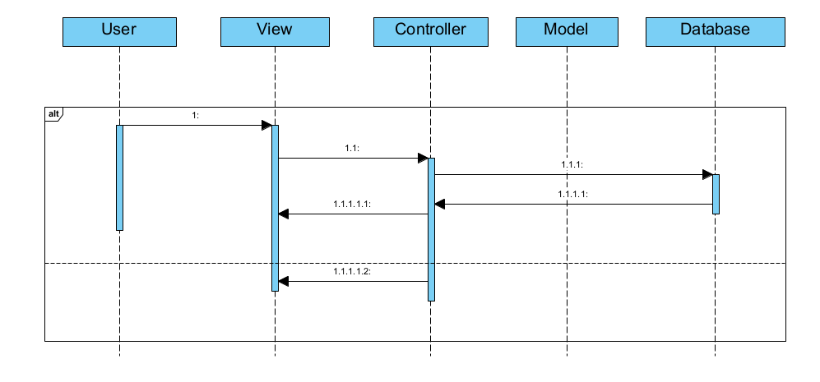
Describe the sequence of messages outlined in the sequence diagram.

Testing Plan
Create a testing plan is based on the normal, Alternate and Exceptional flows in each Use Case Description.

Provide details of the results of this plan.

Use Selenium or Playwright to create tests of your application.

Test the Non-Function requirements of your App using the Chrome developer tools.

Carry out DAST testing on both the Secure and Insecure Branches of your Code using ZAP.
Highlight any Vulnerabilities raised by the tool.

Testing Strategy overview

Functional testing – Manual + Playwright (validate normal, alternate and exceptional flows)
Security Testing (DAST) – OWASP ZAP (Identify runtime vulnerabilities)
Non-functional testing – Chrome Lighthouse (Measure performance, security and usability)
Regression Testing – Playwright (Ensure secure fixes do not break functionality)

Use Case Based Testing Plan

UC-01 Register account

Test Type | Input | Expected Result | Actual Result
Normal | Valid name, email, strong password | Account created | Pass
Alternate | Email already exists | Error message | pass
Exceptional | SQL injection in email | Account created | Vulnerable
Exceptional | SQL Injection in secure version | Blocked | Pass

UC-02 Login user

Test Type | Input | Expected Result | Actual Result
Normal | Valid name, email, strong password | Login success | Pass
Alternate | Wrong password | Error message | pass
Exceptional | ‘ OR ‘1’ = ‘1 | Login bypass | Insecure
Exceptional | Secure SQL injection | Blocked | Secure

UC-03 View events
Test Type | Input | Expected Result | Actual Result
Normal | User logged in | Events displayed | Pass
Exceptional | XSS script in event title | Script executes | Insecure
Secure version | Same attack | Sanitised output | Blocked

UC-04 Register for event
Test Type | Input | Expected Result | Actual Result
Normal | Valid event | Registration success | Pass
Alternate | Already registered | Error shown | Pass
Exceptional | CSRF attack | Registered succeeds | Insecure
Secure | CSRF token missing | Blocked | Pass

UC-05 Create Blog Post
Test Type | Input | Expected Result | Result
Normal | Safe content | Post saved | Pass
Exceptional | <script>alert(1) </script> | Script executes | Stored XSS
Secure | Same input | Output sanitised | Pass

Discussion on the Insecure Code:
Explain the following vulnerabilities and illustrate how you implemented them in your application. Reference the OWASP Top 10 in your answer.
- SQL Injection.
- XSS.
- Sensitive Data Exposure.

Why are they so dangerous?
How a hacker could exploit these vulnerabilities
Provide screen shots of the code.
Provide a screen shot of these vulnerabilities in action in your application.

Discussion on the Secure Code:
Explain how you secured your application from the SQL injection XSS vulnerability and how use mitigated the Sensitive Data Exposure. Reference the OWASP Cheat sheets as to the available options to secure the application.

Discuss how you incorporated proper logging and monitoring. Make a reference to the
What security headers were added and explain why they improved the security.

Ethics Question:
You are working as a contractor in a large software development company you like the work and the organisation and any future work will depend on how you get on with the lead developer. During the final stage of the project, you are tasked with alpha testing and performing a code review where you discover a major vulnerability that would seriously affect the confidentiality integrity and availability of sensitive data held by the organisation. This discovery was only possible because of a penetration test that you had performed for a different client but as part of that test, you signed a letter of engagement which included a non-disclosure clause. You advised the lead developer of your findings and because of a lack of time to fix that problem, he does not want to do anything about it.
Consider three of the Software Engineering Code of Ethics principles and describe what you are going to do about the ethical issues raised by this scenario.

Answer

Appendix A Breakdown of Marks
Section | Description | % mark
1 | Software Development Lifecycle justification | 10%
2 | Software Requirement Specification | 20%
3 | The Use of GitHub for code and project planning | 5%
4 | Discussion of Insecure code implementation | 20%
5 | Discussion of Secure code implementation | 20%
6 | Testing Documentation and results | 10%
7 | Short video demonstrating your project | 5%
8 | Ethics | 10%

Appendix B
Link to GitHub:

Link to Video Demonstration:

